Installation Guide



Explore and Checkout (LWC Omniscript + DC LWC)

**Table Of Contents**

**Installing the Org DX DataPack** **4**

**Installing Vlocity DC Omniscripts MultiPack** **6**

**Launching a Digital Commerce Sample OmniScript** **6**

**Downloading and using the NDS (Newport Design System) file.** **6**

# 

# 

# 

# 

# 

# 

# 

Access to the Vlocity Process Library requires acceptance of the disclosure below:

**RESTRICTED CONTENT: AUTHORIZED USE ONLY**

***The content on the following pages is intended to be viewed only by Vlocity employees, contractors who have been authorized by Vlocity or customers who have been authorized by Vlocity. The content should be considered the sensitive confidential information of Vlocity and is protected under the nondisclosure agreement entered into between your party and Vlocity. Accordingly, further distribution is prohibited without prior written consent from Vlocity.***

***I Accept Vlocity’s Terms and Conditions*** [***https://vlocity.com/terms***](https://vlocity.com/terms)

# 

# **Installing the** **Org DX DataPack**

This DataPack is generated from the DX tool for data creation to run the sample application.

1. Install the latest DX tool from: [https://docs.vlocity.com/en/Vlocity-DX-Desktop-Application.htm](https://docs.vlocity.com/en/Vlocity-DX-Desktop-Application.html)
2. Download the DX org datapack and unzip it.
3. Open the DX tool and select your unzipped DX org DataPack folder as the repository.
4. Select your unzipped DX org DataPack folder as the Source.
5. Select your salesforce org as the target.
6. Click on a new project and specify a name (such as ImportDCOrgData).
7. Select **VlocityTypes** as **all** and **Salesforce Types** as **all**.
8. Click **Fetch DataPacks** and then click **Save**.
9. Click **Migrate With Dependencies** button.

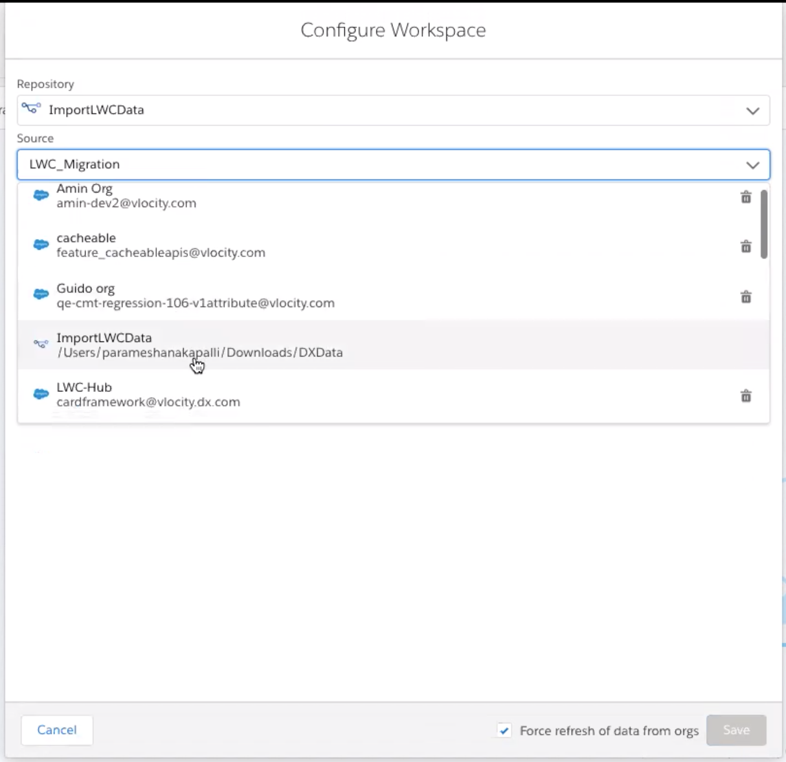

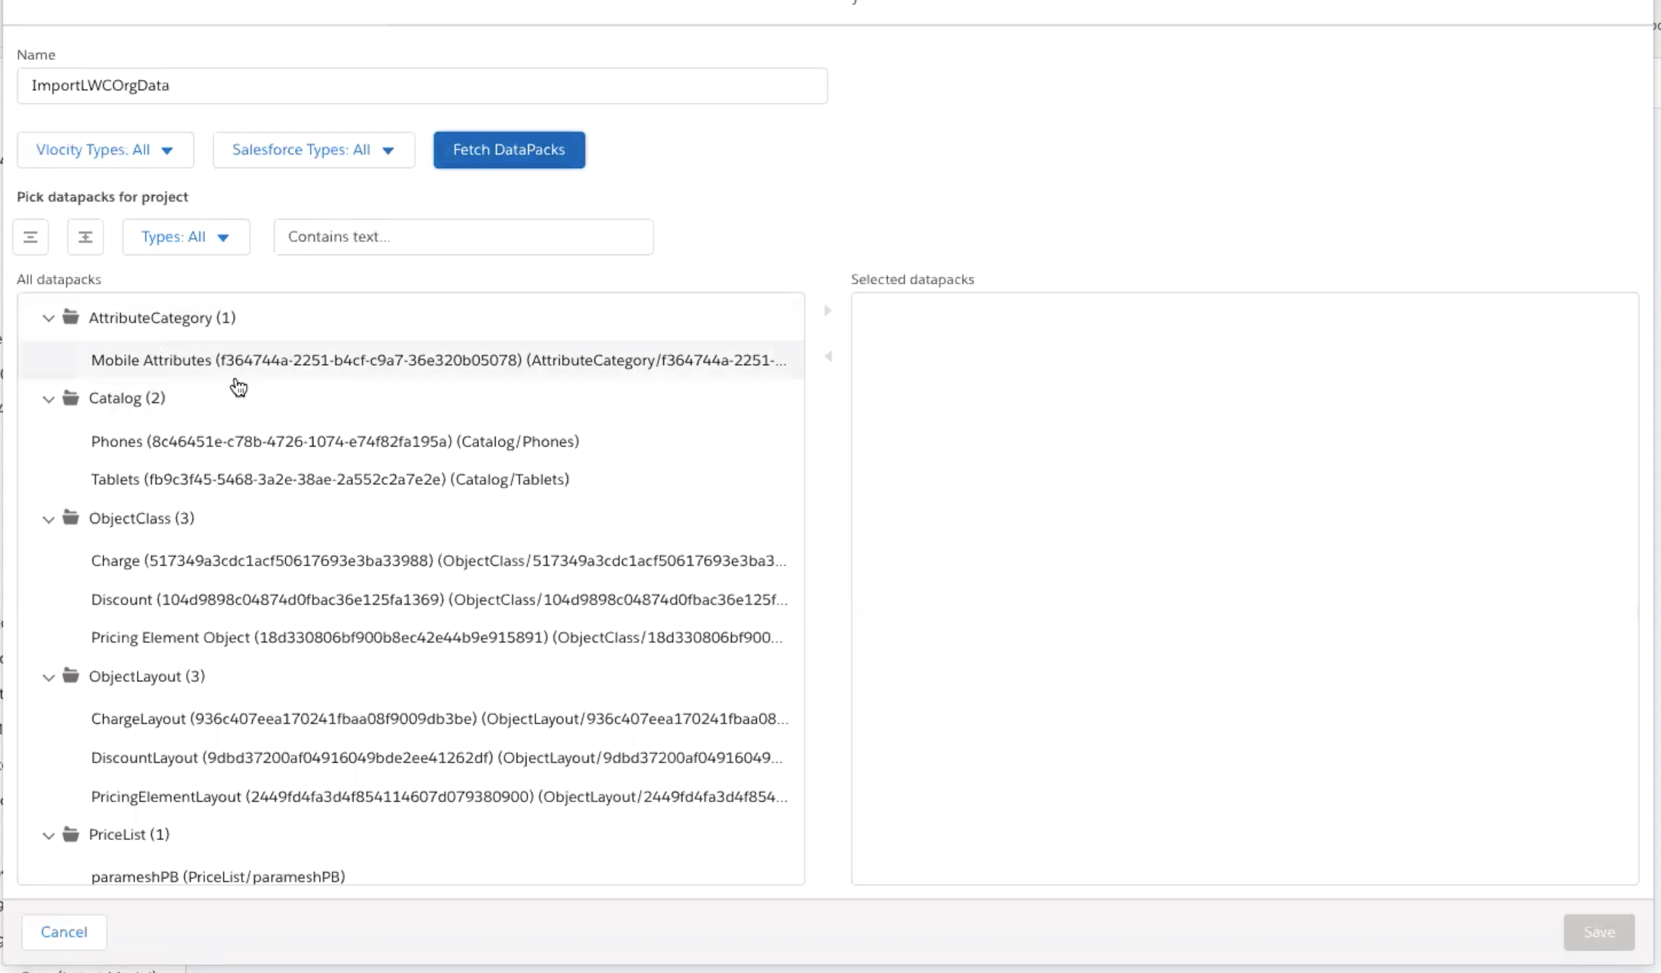

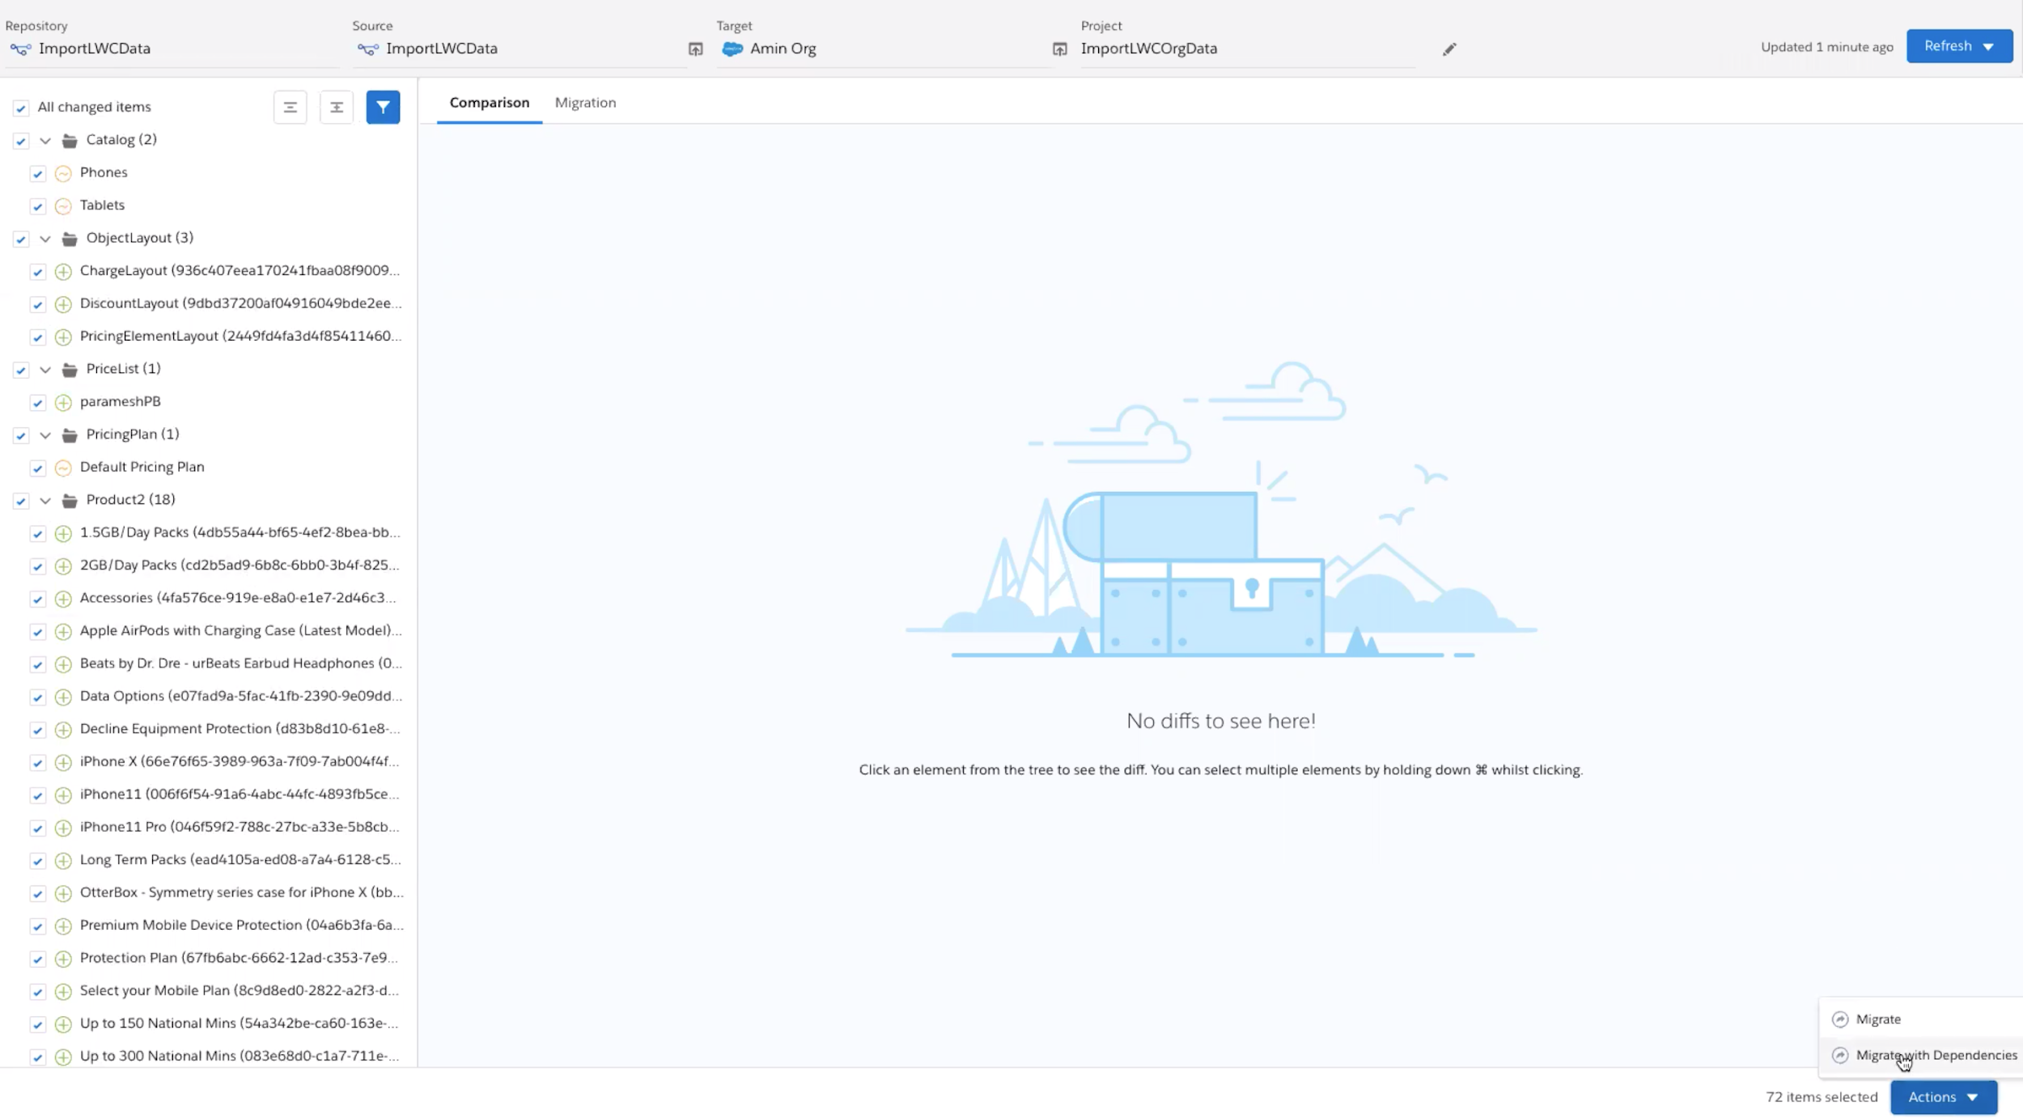

# **Installing Vlocity DC Omniscripts MultiPack**

1. Go to to Vlocity OmniScript Designer.
2. Click **Import**, choose the OS multipack, then click **Next**.
3. Click **Deploy**.

# **Launching a Digital Commerce Sample OmniScript**

1. From the App Launcher (App Launcher icon), find and select **Vlocity OmniScript Designer.**
2. Open **dc/lwc** omniscript.
3. Deploy the omniscript to see LWC Preview. To deploy please Click **Deploy LWC** button.
4. Open the **LWC PREVIEW** tab to run the Digital Commerce OmniScript.

# **Downloading and using the NDS (Newport Design System) file.**

1. Clone the project with the following command: git clone https://github.com/vlocityinc/newport-design-system.git
2. Change to the **newport-design-system** folder using **cd** **newport-design-system**
3. Switch to the correct branch for your version of the package; for example, git checkout v109
4. Run **npm install**
5. Run **npm start** to launch storybook
6. Goto UI/components/digitalcommerce
7. Modify styles as per your requirements.
8. Compile your CSS changes using **npm run build && npm run dist**
9. Go to the dist folder and upload **newport-design-system.zip** file into your org static resources.
10. Name the static resource file; for example, **newport_dc**
11. Select cache Control as public and click **Save**.
12. Open your uploaded static resource newport_dc file again. Right click it and click **copy link address**.
13. Go to Setup and search for **Custom Settings**.
14. Search for **UISettings** and click **manage**.
15. Click the **new** button and create new setting by specifying a name such as **newportZipUrl**
16. Paste the copied URL into the **value** input text box.
17. Refresh your application to see the updated styles.